**FOR TABLES**

-- DEPARTMENT TABLE

CREATE TABLE DEPARTMENT (

DEPARTMENT_ID NUMBER PRIMARY KEY,

DEPT_NAME VARCHAR2(100) NOT NULL

);

-- PROGRAM TABLE

CREATE TABLE PROGRAM (

PROGRAM_ID NUMBER PRIMARY KEY,

PROGRAM_NAME VARCHAR2(100) NOT NULL,

DEPARTMENT_ID NUMBER,

CONSTRAINT FK_PROGRAM_DEPARTMENT

FOREIGN KEY (DEPARTMENT_ID) REFERENCES DEPARTMENT(DEPARTMENT_ID)

);

-- STUDENT TABLE

CREATE TABLE STUDENT (

STUDENT_ID NUMBER PRIMARY KEY,

FNAME VARCHAR2(50) NOT NULL,

LNAME VARCHAR2(50) NOT NULL,

AGE NUMBER(3) CHECK (AGE > 0),

FEE NUMBER(10,2) CHECK (FEE >= 0),

PROGRAM_ID NUMBER,

CONSTRAINT FK_STUDENT_PROGRAM

FOREIGN KEY (PROGRAM_ID) REFERENCES PROGRAM(PROGRAM_ID)

);

-- FACULTY TABLE

CREATE TABLE FACULTY (

FACULTY_ID NUMBER PRIMARY KEY,

NAME VARCHAR2(100) NOT NULL,

JOB_TITLE VARCHAR2(50),

SALARY NUMBER(10,2) CHECK (SALARY >= 0),

DEPARTMENT_ID NUMBER,

CONSTRAINT FK_FACULTY_DEPARTMENT

FOREIGN KEY (DEPARTMENT_ID) REFERENCES DEPARTMENT(DEPARTMENT_ID)

);

-- COURSE TABLE

CREATE TABLE COURSE (

COURSE_ID NUMBER PRIMARY KEY,

COURSE_NAME VARCHAR2(100) NOT NULL,

CREDIT NUMBER(2) CHECK (CREDIT > 0),

DEP_ID NUMBER,

FACULTY_ID NUMBER,

CONSTRAINT FK_COURSE_DEPARTMENT

FOREIGN KEY (DEP_ID) REFERENCES DEPARTMENT(DEPARTMENT_ID),

CONSTRAINT FK_COURSE_FACULTY

FOREIGN KEY (FACULTY_ID) REFERENCES FACULTY(FACULTY_ID)

);

-- ENROLL TABLE

CREATE TABLE ENROLL (

ENROLL_ID NUMBER PRIMARY KEY,

STUDENT_ID NUMBER,

COURSE_ID NUMBER,

SEMESTER VARCHAR2(20),

GRADE CHAR(2),

CONSTRAINT FK_ENROLL_STUDENT

FOREIGN KEY (STUDENT_ID) REFERENCES STUDENT(STUDENT_ID),

CONSTRAINT FK_ENROLL_COURSE

FOREIGN KEY (COURSE_ID) REFERENCES COURSE(COURSE_ID)

);

**LAB#05 – TASK#01**

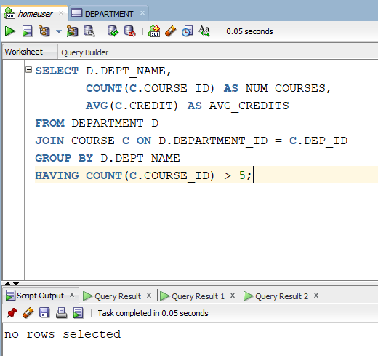

**LAB#05 – TASK#02**

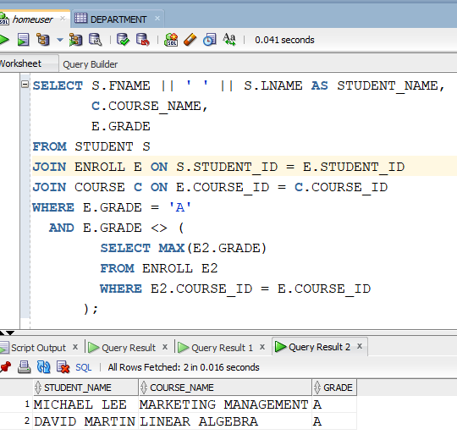

**LAB#05 – TASK#03**

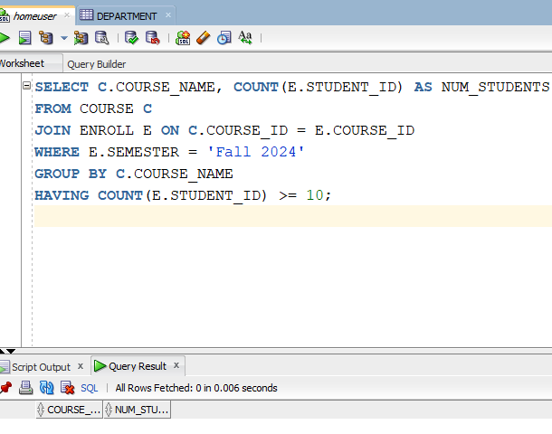

**LAB#05 – TASK#04**

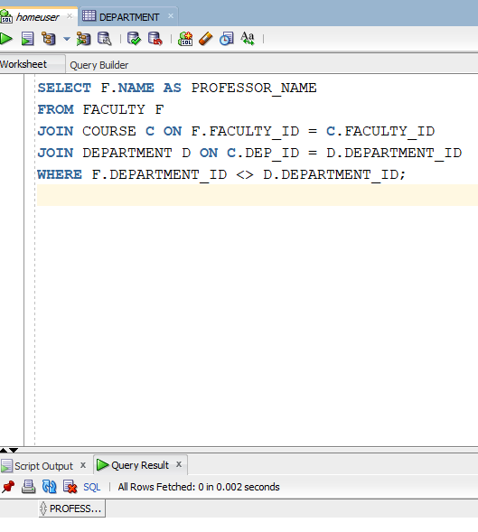

**LAB#05 – TASK#05**

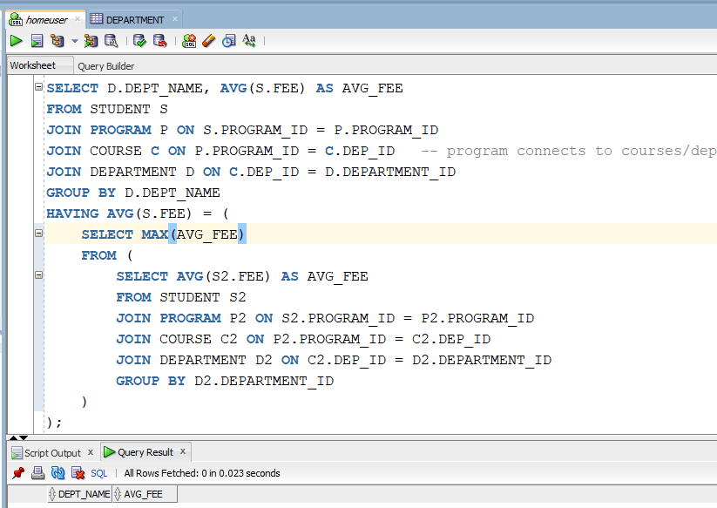

**LAB#05 – TASK#06**

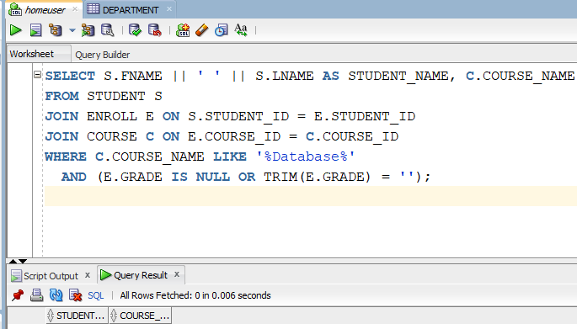

**LAB#05 – TASK#07**

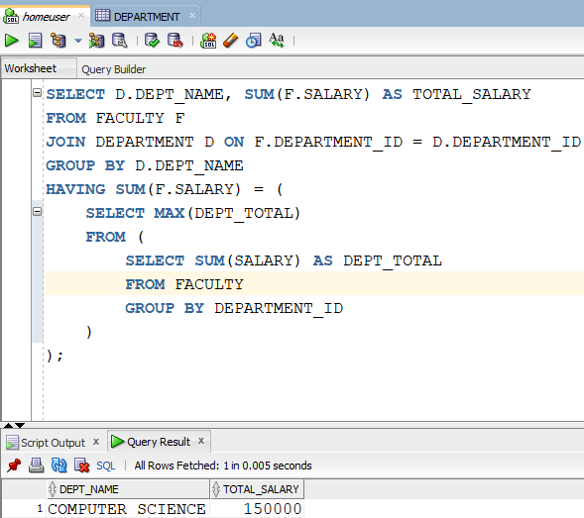

**LAB#05 – TASK#08**

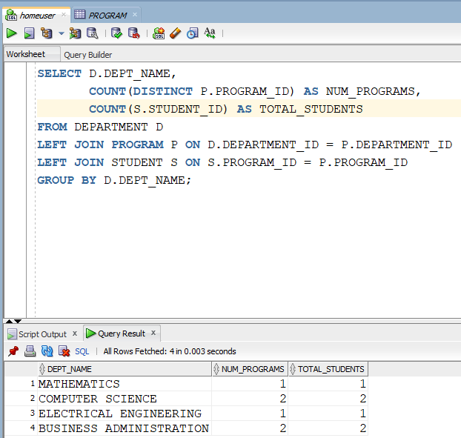

**LAB#05 – TASK#09**

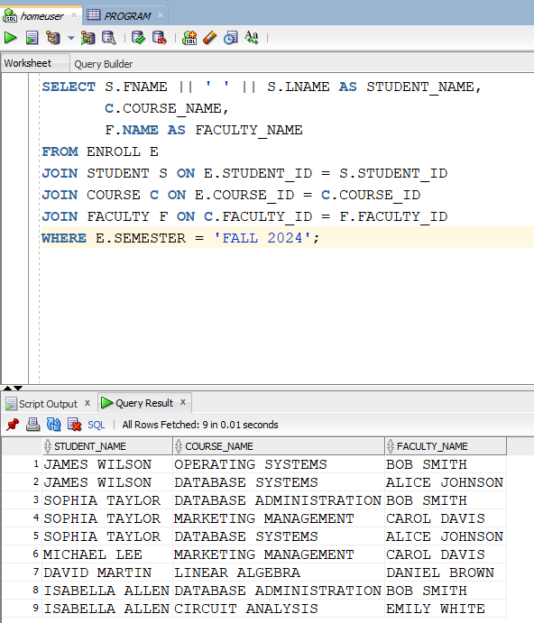

**LAB#05 – TASK#10**

